**Boeing gains its first order in 2020 and**

**Bamboo Airways is getting ready for the International market**

According to **Bloomberg news** posted on February 17th, 2020, **Boeing** is about to receive their first order in 2020 for a 12 **Boeing 777X**, their brand new aircraft, which is still under-development. The deal is expecting to have a market value of 5 billion dollars, subject to bulk discount. However, the detail of this deal is still a secret. This unexpected order came from a Vietnamese Air Carrier, **Bamboo Airways**, join the air carrier market just within a year but has grown tremendously, with a **mixed fleet** of short-haul and long-haul aircraft. This order will help Boeing throughout a hard time, especially after two tragedies with the **Boeing 737MAX** that caused fatalities of more than 500 people and significantly reduce the amount of **delivered aircraft** for Boeing.

**Sources**

* (Boeing Logo) <https://marketbusinessnews.com/the-boeing-company-company-information/15392/>

(General Information & Boeing 777X Image) <https://www.bloomberg.com/news/articles/2020-02-17/bamboo-airways-in-talks-to-buy-12-boeing-777x-planes-quyet>

* (Bamboo Logo and Fleet Details) <https://www.planespotters.net/airline/Bamboo-Airways>
* (Boeing 737 Max Image) <https://www.cnn.com/2019/03/10/africa/ethiopian-airlines-crash-boeing-max-8-intl/index.html>
* (Boeing 737 Max Grounding) <https://www.flightradar24.com/blog/the-boeing-737-max-grounding/>

**Image 1:**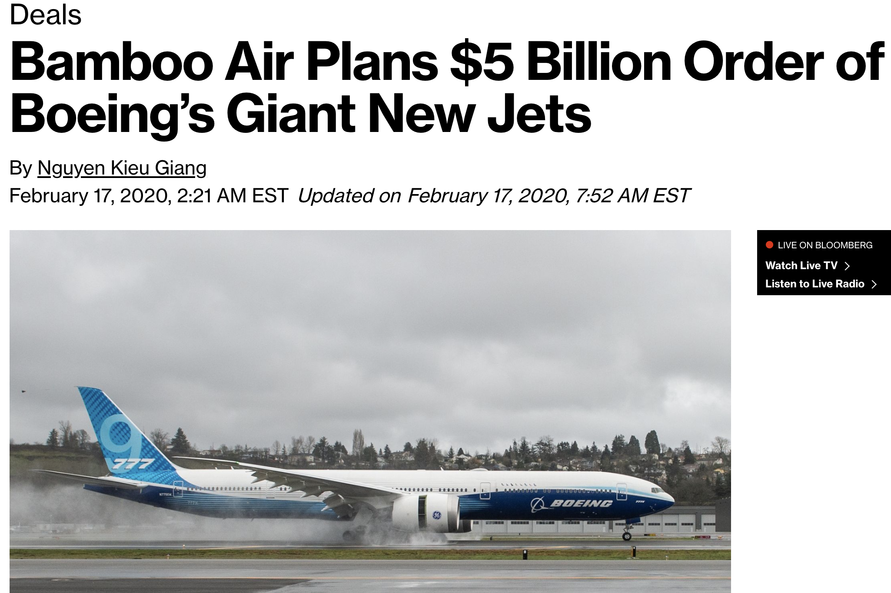

**Image 2:**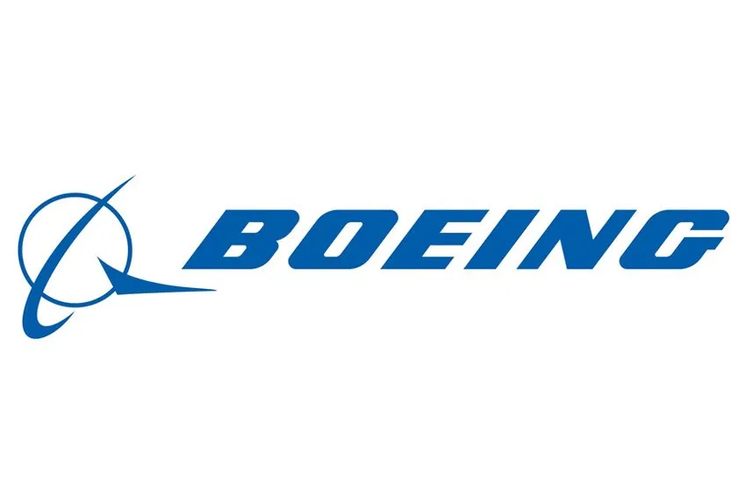

**Image 3:** 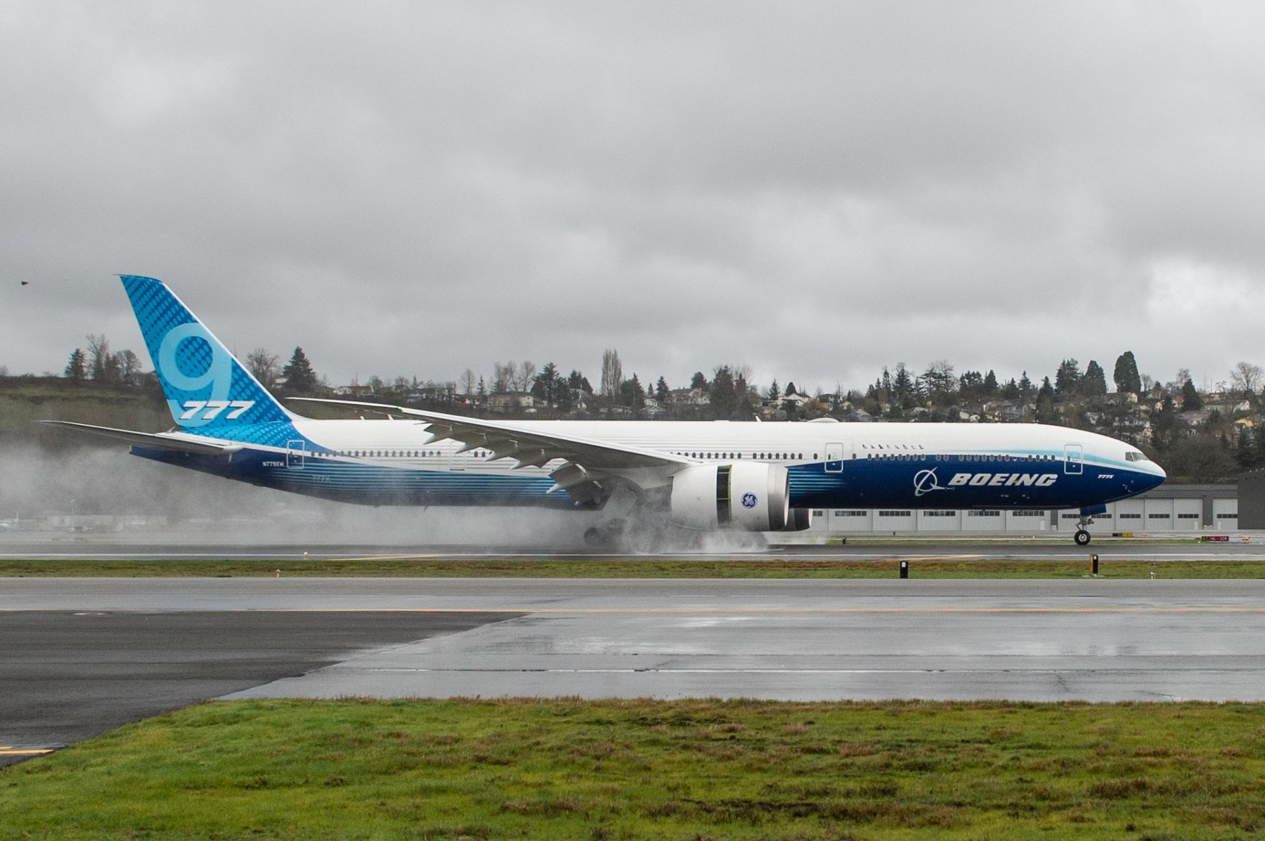

**Image 4:**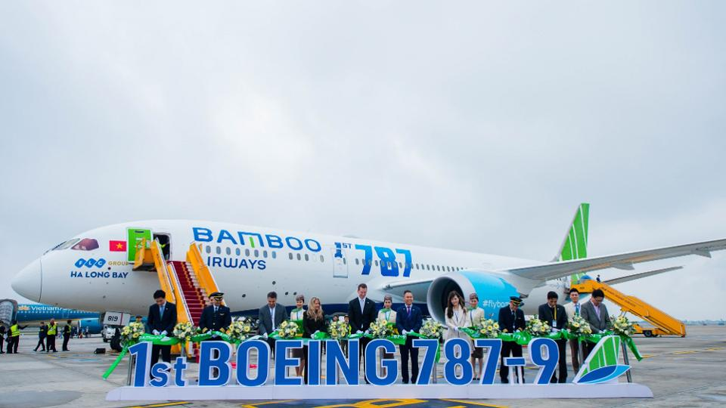

**Image 5:** 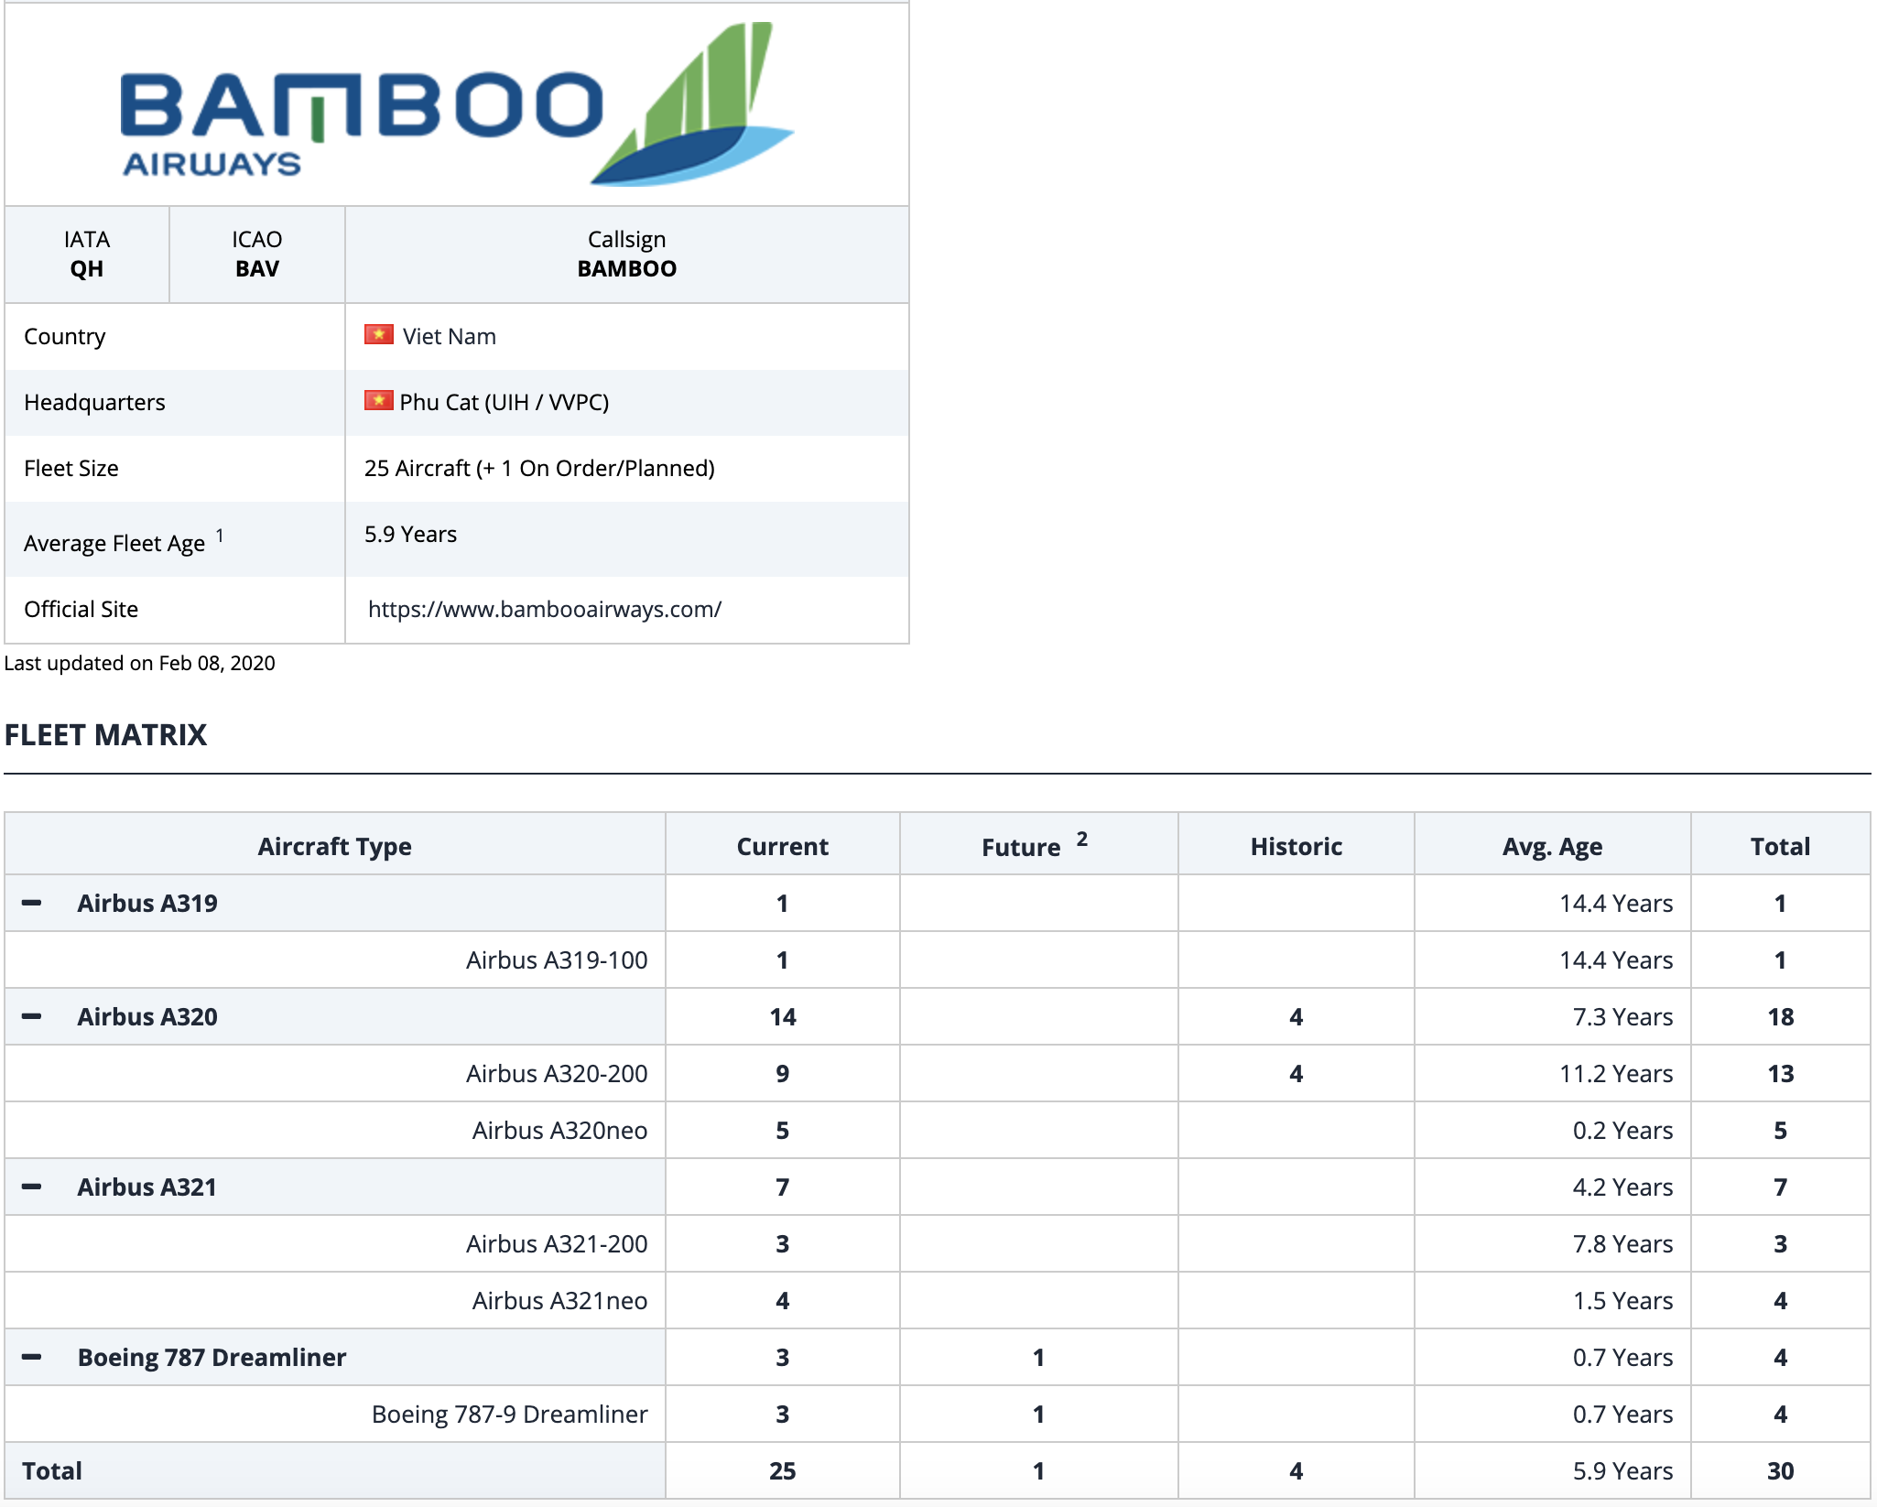

**Image 6:** 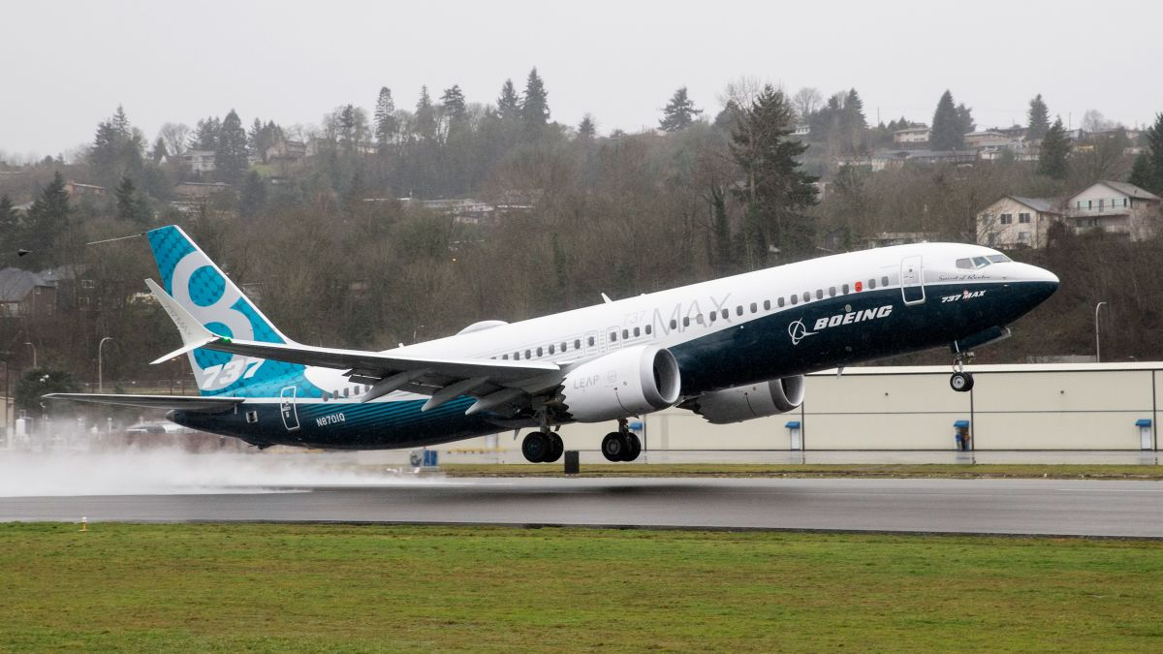

**Image 7:** 